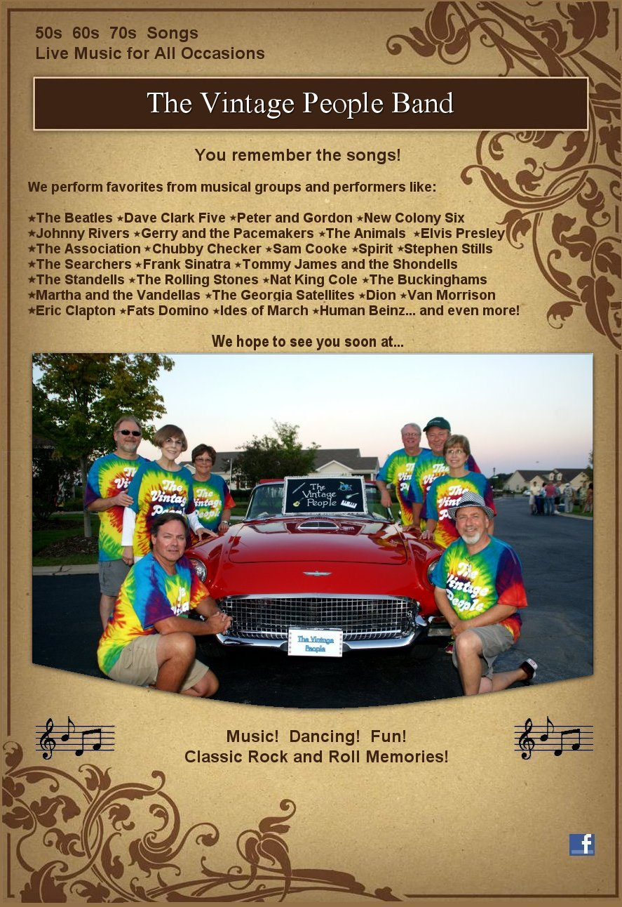

Visit our website at:
http://thevintagepeopleband.weebly.com

http://www.facebook.com/TheVintagePeopleBand

