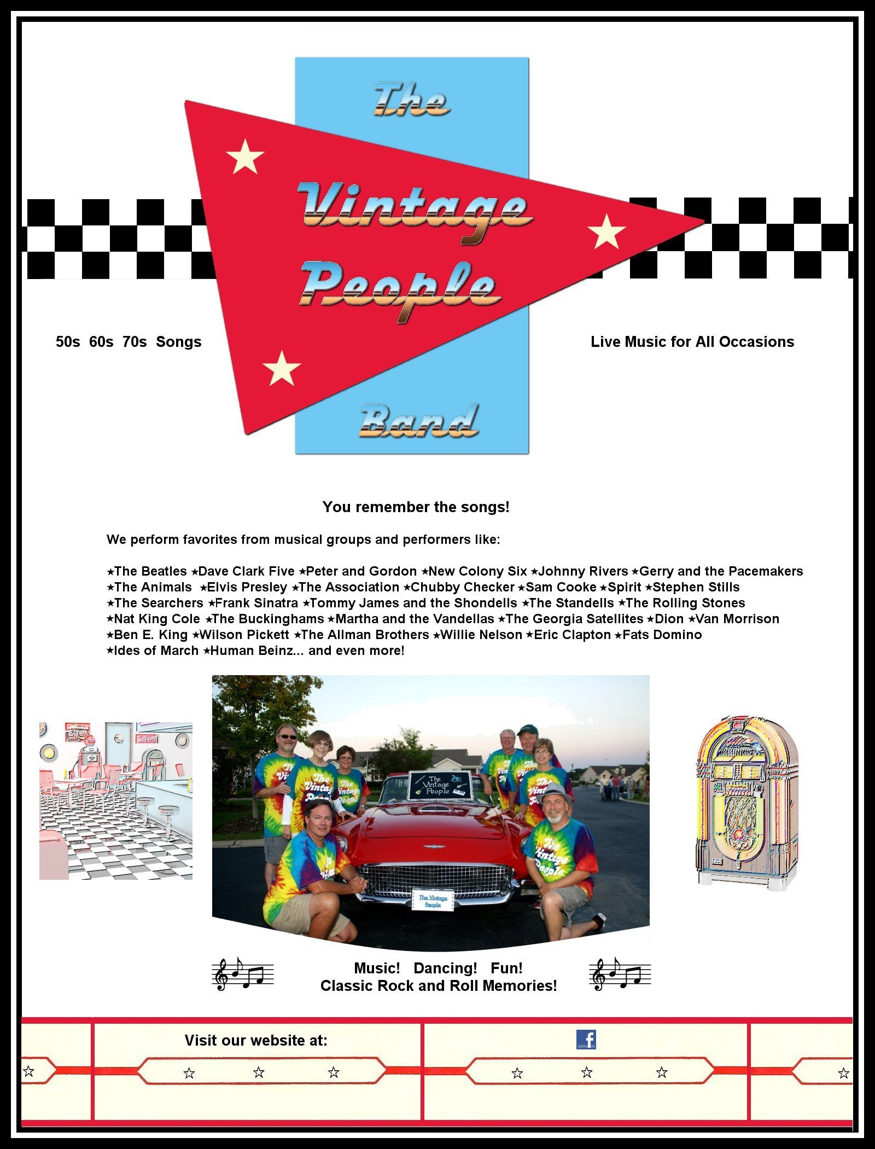

http://thevintagepeopleband.weebly.com http://www.facebook.com/TheVintagePeopleBand

